**Practical-5**

**Aim: Create the function oriented diagram: Data flow diagram.**

**5.1 Data Flow Diagram:**

**5.1.1 Introduction:**

A Data Flow Diagram (DFD) is a traditional visual representation of the information flows within a system. A neat and clear DFD can depict the right amount of the system requirement graphically. It can be manual, automated, or a combination of both.

It shows how data enters and leaves the system, what changes the information, and where data is stored.

The objective of a DFD is to show the scope and boundaries of a system as a whole. It may be used as a communication tool between a system analyst and any person who plays a part in the order that acts as a starting point for redesigning a system. The DFD is also called as a data flow graph or bubble chart.

**5.1.2 Symbols used in DFD diagram:**

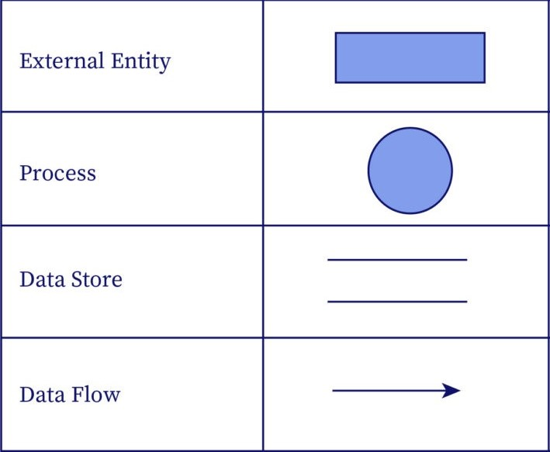

**5.1.3 Zero Level DFD diagram for Propre Cuisine System:**

**5.1.4 1st Level DFD diagram for Propre Cuisine System:**